Fall & Winter NuStair Care

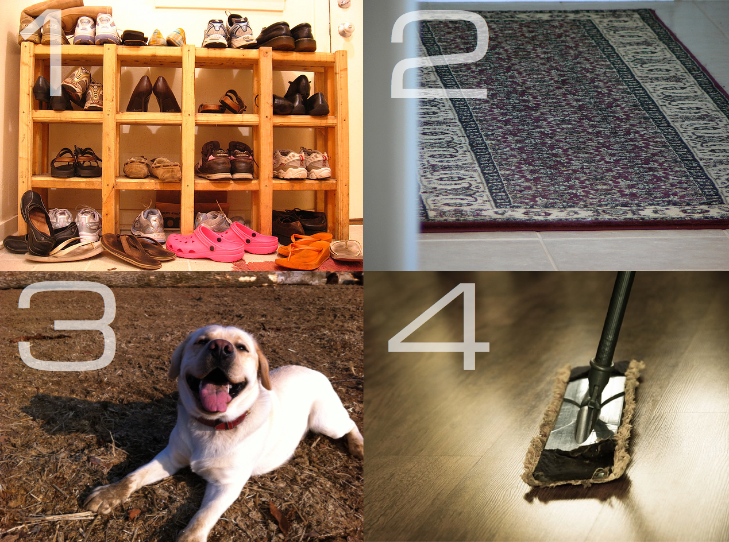

Fall is upon us with the promise of a long winter ahead. This brings with it a whole new set of challenges and considerations regarding caring for your brand newly remodeled hardwood staircase and keeping it looking as new as the day you installed it!

The snow and rain that makes this time of year so magical outside can also make it a soggy puddle inside. If left unattended, excess water can warp wood. (If you have hardwood flowing, this can also cause gapping between boards.) Dry leaves, winter precipitation and salt that get tracked into the house add up to a lot of excess debris on your stairs throughout the fall and winter months. These particles, as minuscule as they may seem, can scratch the protective finish and damage your tread.

While hardwood stairs are undoubtedly easier to keep clean and nice than their carpeted counterparts, the steps are a little different (if you’ll excuse the pun!)

Step 1: Ditch the Shoes

The easiest way to combat excess debris and moistures this fall and winter is to simply remove shoes when you come inside or prior to going upstairs. Try placing a special basket or rack at the foot of the stair to remind family members to remove their wet shows and give them a clean and tidy way to let them dry. (Here are some cool DIY shoe rack ideas that you might enjoy!)

Step 2: Add More Rugs

Increase rugs – decrease moisture and debris. Most household have doormats year round, but consider place a few more inside for these coming months. Keep a rug both inside and outside your exterior doors as well as at the foot of your stairs.

Step 3: Train Your Pets

Our four-legged family members are often the biggest culprit when it comes to tracking unwanted mud, particles and moisture into the house. Train your pet to sit when they come inside the door allowing you to wipe their paws with a clean cloth. You’d be surprised how easy this really is I you keep a bowl of treats by the front door!

Step 4: Sweep You Stairs

We know you already do this, but do it twice as often. Find a quick and easy method to dust your stairs and keep it handy. If those particles do make it onto you stairs, we want their stay to be short and sweet. Our customers have recommended a variety of methods including a simple soft dry cloth, a small broom, electrostatic dusters and more.

Got another idea? We’d love to hear them! Comment below or share a photo or a tip on our Facebook page!

